**Data Flow Diagram (DFD) for Portfolio Website**

**Level 0 - Context Diagram**

At the highest level, the portfolio website is represented as a single process interacting with external entities.

**Diagram Representation:  
  
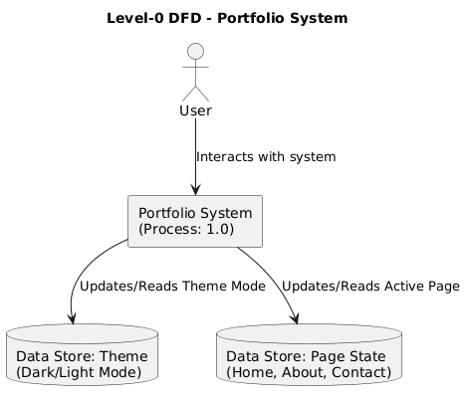**

**Explanation:**

* **External Entity (User):** Interacts with the portfolio website by navigating between pages and toggling dark mode.
* **Process (Portfolio Website - 1.0):** Handles page navigation, theme management, and content display.
* **Data Store (Theme):** Stores user preferences for dark or light mode.
* **Data Store (Page State):** Maintains the current active page (Home, About, or Contact).

**Level 1 DFD - Detailed Decomposition**

Now, we break down the Portfolio Website process into more specific sub-processes.

**Diagram Representation:**

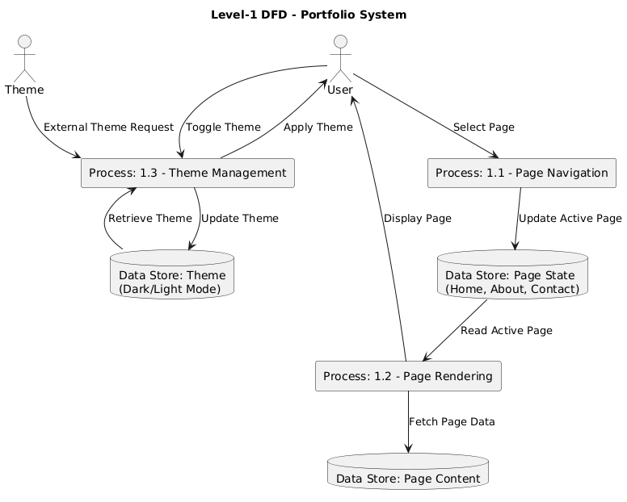

**Explanation:**

1. **Process 1.1 (Page Navigation):** Users click on navigation links, and the active page state updates accordingly.
2. **Process 1.2 (Theme Management):** When the user toggles dark mode, the theme state updates and is stored.
3. **Process 1.3 (Page Rendering):** The active page’s content is fetched and displayed dynamically.

**Data Flow:**

* Users select a page → **Updates Page State** → The corresponding page is rendered.
* Users toggle the theme → **Updates Theme Data Store** → The applied theme changes dynamically.

**Conclusion**

The **Portfolio Website DFD** illustrates how data flows through the system, highlighting user interactions with navigation and theme toggling. This structured breakdown helps developers understand the **state-driven** data flow and ensures smooth updates and re-renders when users interact with the site.